DDA CURVE GENERATION ALGORITHM IN COMPUTER GRAPHICS
Digital differential Analyzer Algorithm uses the differential Equation of curve. The differential Equation for simple curve such as circle is fairly easy to solve .
let us see the DDA algorithm for generating circular arcs.the Equation for an arc in the angle parameters can be gives as
x=R cosϴ+ x0 ……….(1.1)
y=R sinϴ+ y1
where (x0,y0) is the center of curvature,and R is the Radius of arc
Differentiating Equation we get
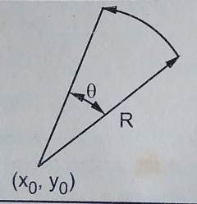
dx = -R sinϴ dϴ
dy = R cosϴ dϴ ….(1.2)
From Equation we can solve for R cosϴ and R sinϴ as follows.
x = R cosϴ = x0
∴ R cos ϴ =x =x0 and
Advertisements
REPORT THIS AD
R sin ϴ =y -y0 …..(1.3)
substituting values of R cos ϴ and R sin ϴ from equation 1.3 in Equation 1.2 we get,
dx = -(y-y0)dϴ and
dx = (x-x0)dϴ
the valuse of dx and dy indicates the increment in x and y increment, respectively, to be
x2 = x1 + dx= x1-(y1-y0)dϴ
y2 = y1 + dy = y1 + (x2- x0)dϴ ……(1.5)
The equation 1.5 forms the basis for arc generation algorithm . Form Equation 1.5 we can see that the next point on the arc is the function of dϴ. To have a smooth curve , the neighbouring points on the arc should be close to each other. to achive this, the values of dϴ
should be small enough not to leave gaps in the arc. Usually, the value of dϴ can be determined from the following Equation.
dϴ =Min (0.01,1/(3.2*(|x -x0| + |y -y0|)))

ALOGORITHM :
- Read the center of a curvature,say (x0,y0)
- Read the arc angle,say ϴ
- Read the Starting point of the arc,say(x,y)
- Calculate dϴ
dϴ =Min (0.01,1/(3.2*(|x -x0| + |y -y0|)))
5. Initialize Angle = 0
6. while (Angle < ϴ)
do {
plot(x,y)
x= x-(y-y0) * dϴ
y = y +(x-x0) * dϴ
Angle = Angle + dϴ
}
7. Stop
computer graphics, we often need to draw different types of objects onto the screen. Objects are not flat all time and we need to draw curves many times to draw an object.

Types of Curves:
The curve is an infinitely large set of points. Each point has two neighbors except endpoints.
- Implicit curves
- Explicit curves
- Parametric curves
- Bezier curves
- B-spline curves

Implicit Curves:
An implicit curve or surface is the set of zeros of a function of 2 or 3 variables. We use implicit curve functions to define lines and planes. Provides no control over tangents at connection points when joining several implicit functions. Implicit functions are hard to find for many shapes. Use a function that states which points are on and off the curves.
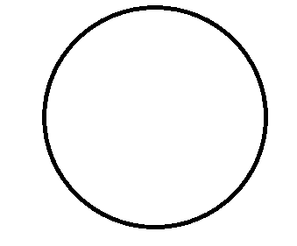

All lines: Ax+By+C=0
In three dimensions f(X,Y, Z) defines a surface.
- Any plane Ax+By+ +D=0, with constants a,b,c, and d.
- A sphere centered at the origin with a radius:
Curves in 3D are not so easily represented in implicit form. In general, we cannot solve for points that satisfy the implicit form.
- Implicit function form – f(x,y) = 0
- The implicit representation for the circle is: X^2+Y^2-R^2=0

Explicit curves:
- Do not allow for multiple values for a given argument
- Cannot describe vertical tangents, as infinite slopes are hard to represent.
- Cannot represent all curves (vertical lines, circles)
Gives the value of one variable, the dependent variable in other terms of the other the independent variable. The most familiar form of the curve in 2D:
Where y is the dependent variable, and x is the independent variable.

Mathematical function:
f = y(x) can be plotted on curve
eg: y = 2X^5+3X^4
y=mx+c

Parametric curves:
Curves have a parametric form called parametric curves. A curve in the plane is said to be parameterized if the set of coordinates on the curves (x,y,z) is represented as a function of a variable t. The variable t is called a parameter and the relations between x,y,z, and t are called a parametric equation

The parametric form of a curve is a function that assigns a position to values of the free parameters. That the parametric function is a vector-valued function. This example is a 2D curve, so the output of the function is a 2-D vector, in 3D it would be a 3 vector. It is simple and flexible
The parametric form is suitable for representing closed and multivalued curves. In parametric curves, each coordinate of a point on a curve is represented as a function of a single parameter. There are many curves that we cannot write down as a single equation in terms of x and y. The position vector of a point on the curve is fixed by the value of the parameter. Since a point on a parametric curve is specified by a single value of the parameter, the parametric form is axis-dependent. The function of each coordinate can be defined independently

Eg: x=acost; y=asint

Bezier curves:
A bezier curve is particularly a kind of spline generated from a set of control points by forming a set of polynomial functions. Discovered by the french engineer Pierre bezier. These functions are computed from the coordinates of the control points. These curves can be generated under the control of other points. Tangents by using control points are used to generate curves.
It is an approximate spline curve. A bezier curve is defined by the defining polygon. It has no properties that make them highly useful and convenient for curve and surface design.

Different types of curves are Simple, Quadratic, and Cubic.
- Simple curve: Simple bezier curve is a straight line from the point.
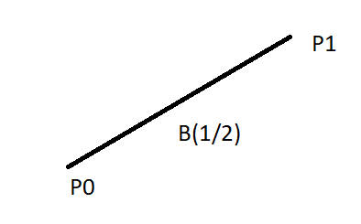
Simple
2. Quadratic curve: Quadratic bezier curve is determined by three control points.
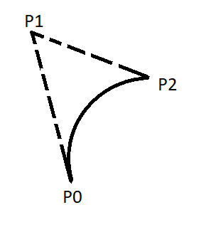
Quadratic
3. Cubic curve: The cubic bezier curve is determined by four control points.
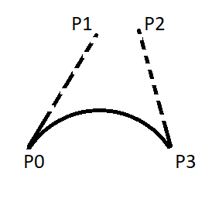
cubic

Properties of Bezier Curve:
- Bezier curves are widely available and used in various CAD systems, in general graphics packages such as GL
- The slope at beginning of the curve is along the line joining the first two control points and the slope at the end of the curve is along the line joining the last two points
- Bezier curve always passes through the first and last points i.e p(o)=po, p(1,=pnlie)
- The curves lies entirely within the convex hall formed by the four control points
- The slope at the beginning of the curve is along the line joining the first two control points and the slope at the end of the curve is along the line joining the last two points.
- The degree of polynomial defining the curve segment is one less than the no of defining the polygon.

Bezier Curve for 3 Points:
Q(u)=PoBo12(u)+P1B1,2(u)+P2B2,2(u)
- B0,2(u)=2Co*+u^0(1-u)*^2-0
= (1-U)^2
- B1,2(u)=2C1*U^1(1-u)*^2-1
= 2u(1-u)
- B2,2(u)=2C2*U^2(1-u)*^2-2
=u^2
Q(u)=P0(1-u)^2+P1*2u(1-u)+P2U^2
X(u)=(1-u)^2*X0+2U*(1-u)*X1+u^2*x2
Y(u)=(1-u)^2*y0+2u*(1-u)*y1
- Bezier curves exhibit global control points means moving control points alert the shape of the whole curve.
Different varieties of spline curves are used in graphics applications.
- Hermit spline
- Relaxed end spline
- Cyclic spline
- Anti cyclic spline
- Normalized spline

B-spline curves:
the sum of the b-spline basic function at any parametric ‘u’ equal to 1
Summation of i from 1 to n+1 nik(u)=1
n+1= no of control points;
k=order of b-spline curve
We can add/modify any no of control points to change the shape of the curve without affecting the degree of polynomial .Control points affect the shape of the curve only over range of parameter values where is associated basic function is non-zero. The polynomial curve has degree (d-1) and C^d-2 continuity over the range of u. Where each blending function is defined our d sub intervals of the total range of u. The selected set of subintervals endpoints u is referred to as a knot vector. The basic function is positive or zeroes for all parameter values. Expect for k=1 each basis function has one maximum value.
What is Koch Curve?
The Koch snowflake (also known as the Koch curve, Koch star, or Koch island) is a mathematical curve and one of the earliest fractal curves to have been described. It is based on the Koch curve, which appeared in a 1904 paper titled “On a continuous curve without tangents, constructible from elementary geometry” by the Swedish mathematician Helge von Koch.
The progression for the area of the snowflake converges to 8/5 times the area of the original triangle, while the progression for the snowflake’s perimeter diverges to infinity. Consequently, the snowflake has a finite area bounded by an infinitely long line.

Construction
Step1:
Draw an equilateral triangle. You can draw it with a compass or protractor, or just eyeball it if you don’t want to spend too much time drawing the snowflake.
• It’s best if the length of the sides are divisible by 3, because of the nature of this fractal. This will become clear in the next few steps.
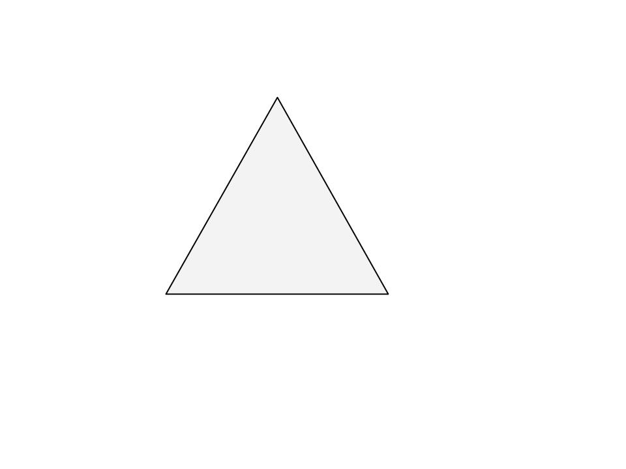
Step2:
Divide each side in three equal parts. This is why it is handy to have the sides divisible by three.
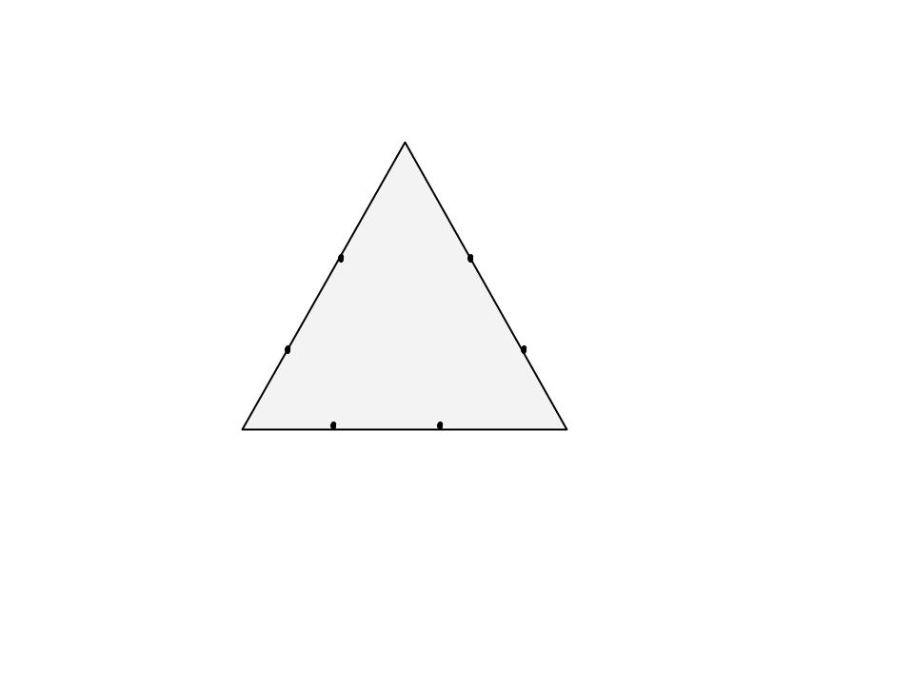
Step3:
Draw an equilateral triangle on each middle part. Measure the length of the middle third to know the length of the sides of these new triangles.
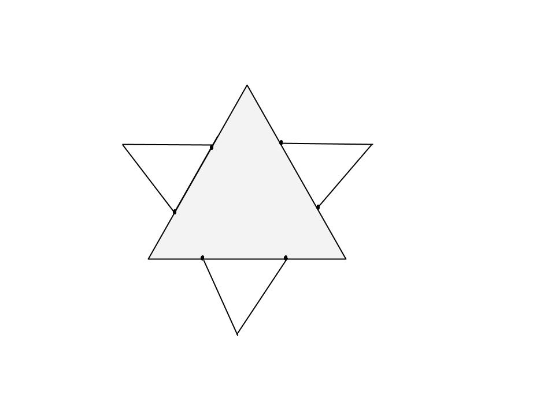
Step4:
Divide each outer side into thirds. You can see the 2nd generation of triangles covers a bit of the first. These three line segments shouldn’t be parted in three.
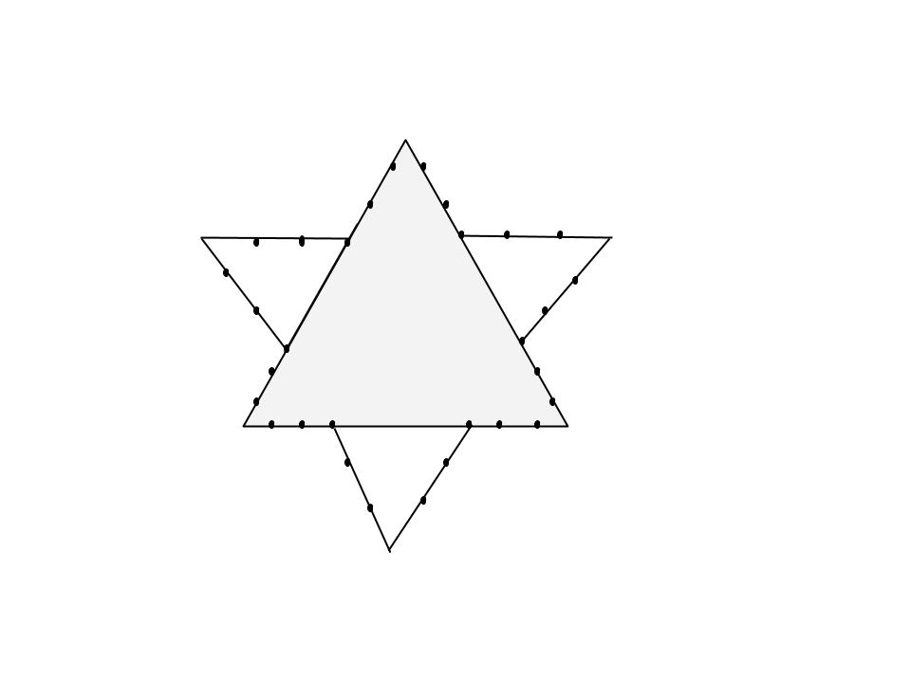
Step5:
Draw an equilateral triangle on each middle part.
• Note how you draw each next generation of parts that are one 3rd of the mast one.
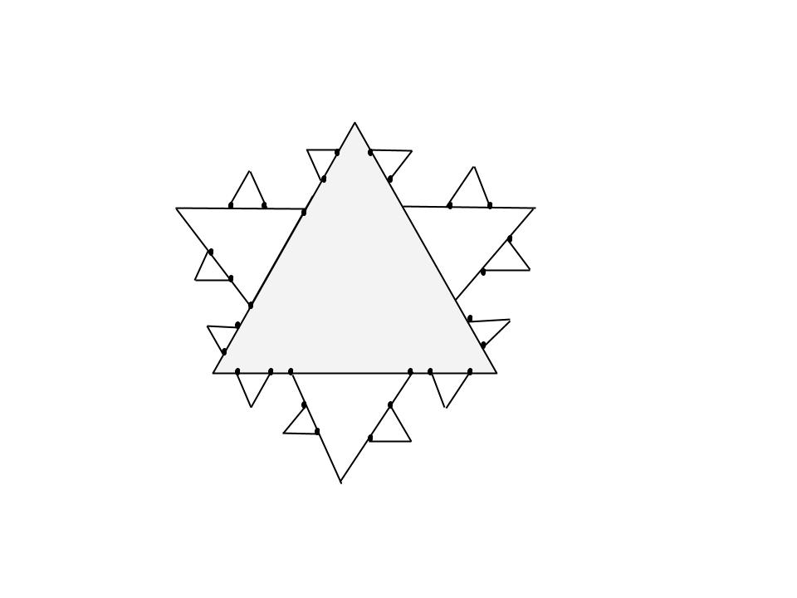

Representation as Lindenmayer system

The Koch curve can be expressed by the following rewrite system (Lindenmayer system):
Alphabet : F
Constants : +, ?
Axiom : F
Production rules: F ? F+F–F+F
Here, F means “draw forward”, – means “turn right 60°”, and + means “turn left 60°”.
To create the Koch snowflake, one would use F++F++F (an equilateral triangle) as the axiom.

To create a Koch Curve :
# Python program to print partial Koch Curve.
# importing the libraries : turtle standard
# graphics library for python
from turtle import *

#function to create koch snowflake or koch curve
def snowflake(lengthSide, levels):
if levels == 0:
forward(lengthSide)
return
lengthSide /= 3.0
snowflake(lengthSide, levels-1)
left(60)
snowflake(lengthSide, levels-1)
right(120)
snowflake(lengthSide, levels-1)
left(60)
snowflake(lengthSide, levels-1)

# main function
if __name__ == "__main__":

# defining the speed of the turtle
speed(0)
length = 300.0

# Pull the pen up – no drawing when moving.
penup()

# Move the turtle backward by distance,
# opposite to the direction the turtle
# is headed.
# Do not change the turtle’s heading.
backward(length/2.0)

# Pull the pen down – drawing when moving.
pendown()

snowflake(length, 4)

# To control the closing windows of the turtle
mainloop()
Output:
Video Player
00:00
00:11
To create a full snowflake with Koch curve, we need to repeat the same pattern three times. So lets try that out.
# Python program to print complete Koch Curve.
from turtle import *

# function to create koch snowflake or koch curve
def snowflake(lengthSide, levels):
if levels == 0:
forward(lengthSide)
return
lengthSide /= 3.0
snowflake(lengthSide, levels-1)
left(60)
snowflake(lengthSide, levels-1)
right(120)
snowflake(lengthSide, levels-1)
left(60)
snowflake(lengthSide, levels-1)

# main function
if __name__ == "__main__":
# defining the speed of the turtle
speed(0)
length = 300.0

# Pull the pen up – no drawing when moving.
# Move the turtle backward by distance, opposite
# to the direction the turtle is headed.
# Do not change the turtle’s heading.
penup()

backward(length/2.0)

# Pull the pen down – drawing when moving.
pendown()
for i in range(3):
snowflake(length, 4)
right(120)

# To control the closing windows of the turtle
mainloop()
Output:
Video Player
00:00
00:20

This article is contributed by Subhajit Saha. If you like GeeksforGeeks and would like to contribute, you can also write an article using contribute.geeksforgeeks.org or mail your article to contribute@geeksforgeeks.org. See your article appearing on the GeeksforGeeks main page and help other Geeks.
Please write comments if you find anything incorrect, or you want to share more information about the topic discussed above.

Fractals in C/C++

A
akankshajolly

• Read
• Discuss
• Courses
• Practice

A Fractal is a never-ending pattern. Fractals are infinitely complex patterns that are self-similar across different scales. They are created by repeating a simple process over and over in an ongoing feedback loop. Mathematically fractals can be explained as follows.
- The location of a point on a screen is fed into an equation as its initial solution and the equation is iterated a large number of times.
- If that equation tends to zero (i.e. the value at the end of the iterations is smaller than the initial value), the point is coloured black.
- If the equation tends to infinity (i.e. the final value is larger than the initial value) then depending on the rate of increase (i.e. the rate at which the value tends to infinity), the pixel is painted with an appropriate colour.
Mandelbrot Set :
The Mandelbrot set is the set of complex numbers c for which the function f_{c}(z) = z² + c does not diverge when iterated from z = 0, i.e, for which the sequence fc(0), fc(fc(0)) etc, remains bounded in absolute value.
The Mandelbrot set is the set of values of c in the complex plane for which the orbit of 0 under iteration of the quadratic map Z_{n+1} = Z_{n}² + c remains bounded. That is, a complex number c is part of the Mandelbrot set if, when starting with Z₀ = 0 and applying the iteration repeatedly, the absolute value of Z_{n} remains bounded however large n gets. Below given is the initial image of a Mandelbrot set zoom sequence. Black points correspond to numbers that are outside the set.
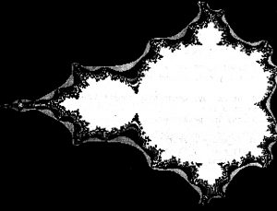
Properties of Mandelbrot Set :
- The Mandelbrot set is a connected set since it always have a path from one point of the set to another point of the set so that all the points in the path are also in the set.
- The Mandelbrot Set has a finite area but infinite length of border.
- The Mandelbrot set is symmetric with respect to the real axis. This means if a complex number belongs to the set then its conjugate will also belong to that set.
- The Mandelbrot set is bounded.
- The Mandelbrot set is itself similar in a non exact sense.
- The border of the Mandelbrot set is a fractal structure with not yet known fractal dimension.
Implementation : Since the concept of Fractals involves the mathematical properties of equations, the algorithm and the programs that create fractals are difficult to write and optimize. One can find many commercial software that create fractals. These programs represent some of the most optimized and probably the best fractal algorithms and implementations that have been created. Below given is the approach :
- For drawing Mandelbrot set, set the pixel that is a complex number.
- Colour the pixel if it belongs to the set.
- Iterate through every pixel and calculate the corresponding complex numbers whose result is saved in c_real for real part and c_imaginary for imaginary part.
- Calculate the Mandelbrot function which is defined as z = z*z + c where z is a complex number.
- Since complex multiplication is difficult, break the equation and calculate the sub parts i.e. the real and the imaginary part separately.
- As square of a complex number (a + ib)² = a² – b² + 2abi, where a² -b² is the real part and 2abi is imaginary part.
- While calculating z, calculate them separately, i.e,
Z_real = z_real*z_real – z_imaginary*z_imaginary + c_real
Z_imaginary = 2*z_real*z_imaginary + c_imaginary
- Continue to calculate these values for each pixel until we reach the maximum iterations and the absolute value of z is not less than 2. Finally, we colour the pixel.
// C++ implementation for mandelbrot set fractals
#include <graphics.h>
#include <stdio.h>
#define MAXCOUNT 30

// Function to draw mandelbrot set
void fractal(float left, float top, float xside, float yside)
{
float xscale, yscale, zx, zy, cx, tempx, cy;
int x, y, i, j;
int maxx, maxy, count;

// getting maximum value of x-axis of screen
maxx = getmaxx();

// getting maximum value of y-axis of screen
maxy = getmaxy();

// setting up the xscale and yscale
xscale = xside / maxx;
yscale = yside / maxy;

// calling rectangle function
// where required image will be seen
rectangle(0, 0, maxx, maxy);

// scanning every point in that rectangular area.
// Each point represents a Complex number (x + yi).
// Iterate that complex number
for (y = 1; y <= maxy - 1; y++) {
for (x = 1; x <= maxx - 1; x++)
{
// c_real
cx = x * xscale + left;

// c_imaginary
cy = y * yscale + top;

// z_real
zx = 0;

// z_imaginary
zy = 0;
count = 0;

// Calculate whether c(c_real + c_imaginary) belongs
// to the Mandelbrot set or not and draw a pixel
// at coordinates (x, y) accordingly
// If you reach the Maximum number of iterations
// and If the distance from the origin is
// greater than 2 exit the loop
while ((zx * zx + zy * zy < 4) && (count < MAXCOUNT))
{
// Calculate Mandelbrot function
// z = z*z + c where z is a complex number

// tempx = z_real*_real - z_imaginary*z_imaginary + c_real
tempx = zx * zx - zy * zy + cx;

// 2*z_real*z_imaginary + c_imaginary
zy = 2 * zx * zy + cy;

// Updating z_real = tempx
zx = tempx;

// Increment count
count = count + 1;
}

// To display the created fractal
putpixel(x, y, count);
}
}
}

// Driver code
int main()
{
// gm is Graphics mode which is
// a computer display mode that
// generates image using pixels.
// DETECT is a macro defined in
// "graphics.h" header file
int gd = DETECT, gm, errorcode;

float left, top, xside, yside;

// setting the left, top, xside and yside
// for the screen and image to be displayed
left = -1.75;
top = -0.25;
xside = 0.25;
yside = 0.45;
char driver[] = "";

// initgraph initializes the
// graphics system by loading a
// graphics driver from disk
initgraph(&gd, &gm, driver);

// Function calling
fractal(left, top, xside, yside);

getch();

// closegraph function closes the
// graphics mode and deallocates
// all memory allocated by
// graphics system
closegraph();

return 0;
}
Output :
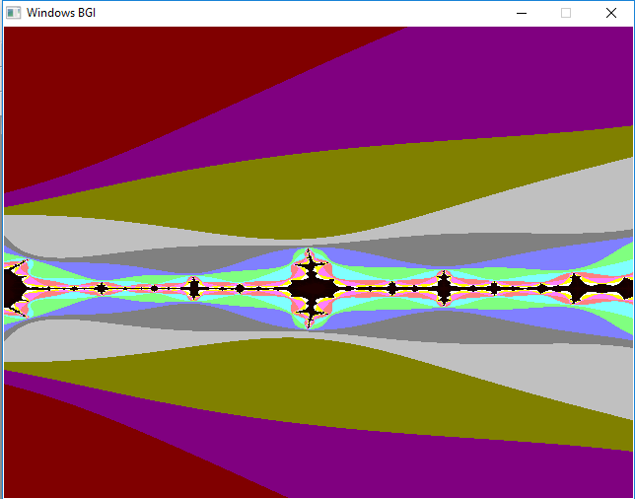
Applications of Fractals : The basic idea of Fractals is to find regularities in the existing irregularities. Below given are some applications of Fractals :
- Fractal image compression is used in computer science, based on the facts of fractal geometry. By using this technique image is much more compressed as compared to JPEG, GIF, etc. Also, there is no pixelization when the picture is enlarged.
- To ease the study of turbulent flows, fractal representation is used. Also, fractals are used to represent porous media which is used in petroleum science.
- Fractal shaped antenna have been recently used which help in reducing the size and the weight of antennas and providing high performance.

